Terraform Task -02
1. Execute all the templates shown in the vedio.
Create a new project on windows and go to File → Open Folder → terraform-project

Create main.tf
In the VS Code Explorer:
- Right-click terraform-project
- Select New File
- Name it: main.tf
From inside the project folder:
Run terraform init
Terraform will download the AWS provider and create a .terraform directory.
You should then have:
terraform-project/
├── .terraform/
├── .terraform.lock.hcl
└── main.tf
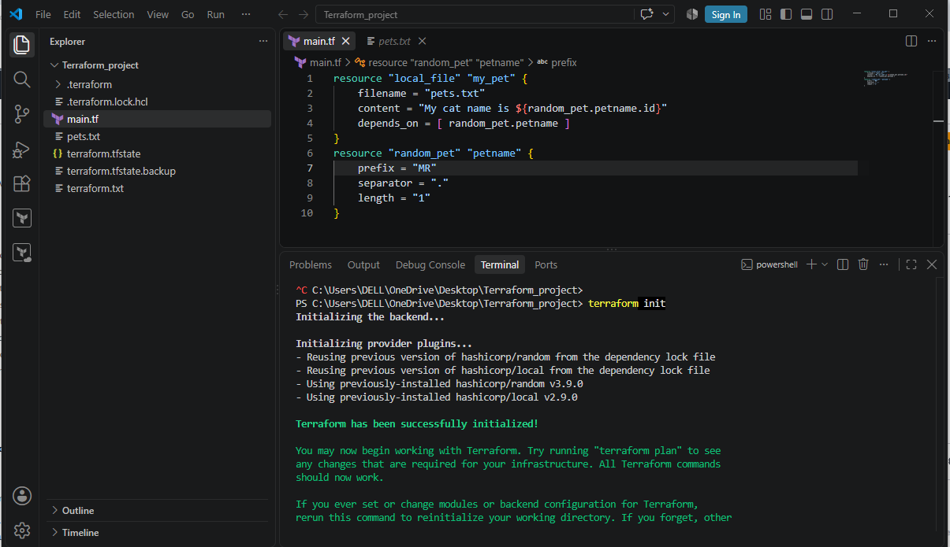

terraform validate, terraform fmt and terraform plan.
Expected:
Success! The configuration is valid.

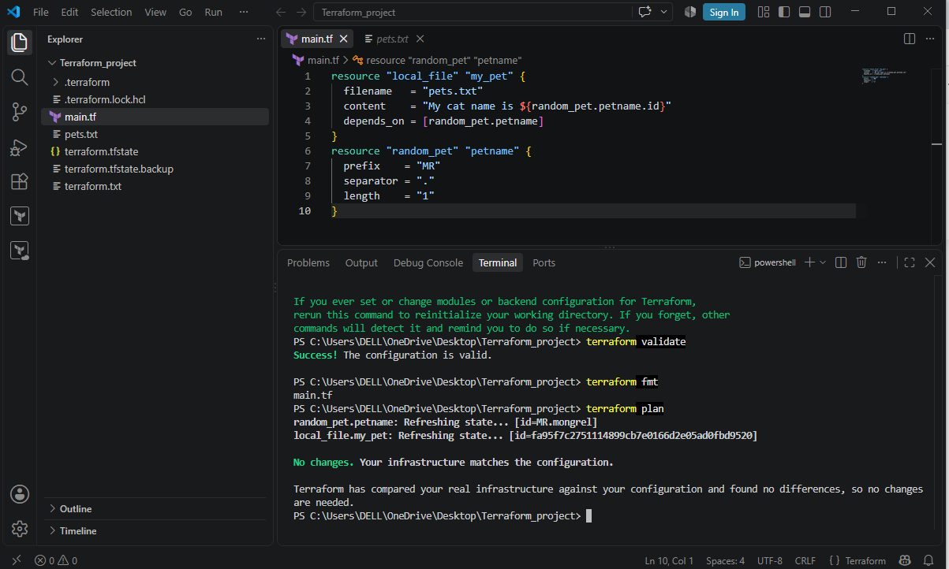
Output file:
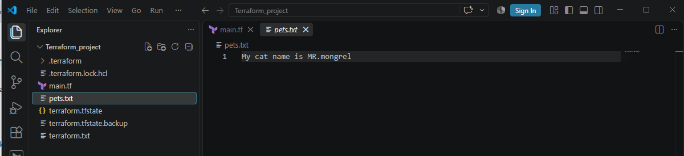

Terraform State File
The Terraform state file is a file Terraform uses to remember the infrastructure it has created and manage it in future operations.
The default state file is: terraform.tfstate
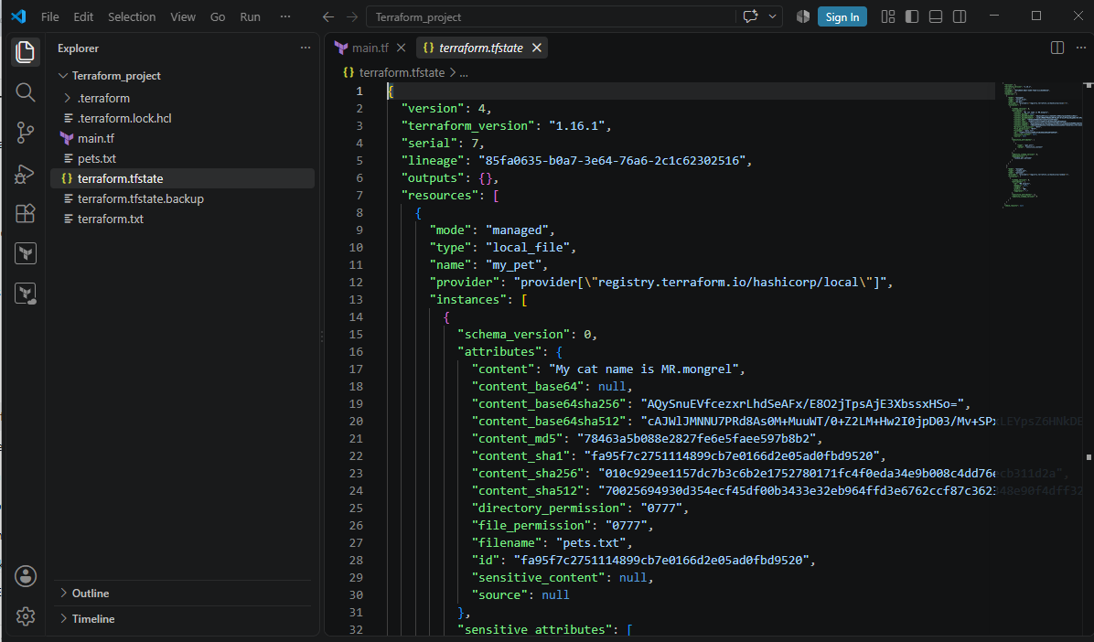
terraform.lock.hcl is a dependency lock file created by Terraform.
Its main purpose is to lock the provider version that your Terraform project uses.
terraform.lock.hcl helps ensure that the project uses the same selected provider version and verified provider package.
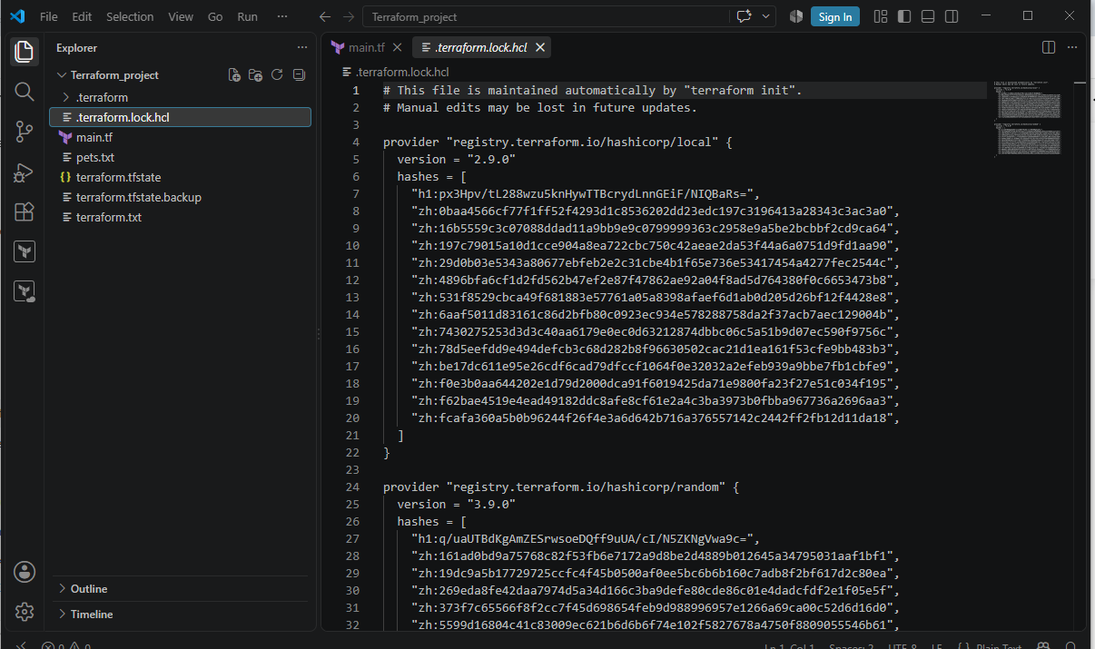

Variable.tf file:
The main purpose of variable.tf is to define input variables so that your Terraform code is reusable, flexible, and easier to change.
Instead of hardcoding values in main.tf, you define variables and use them.
1. By using variable.tf file:
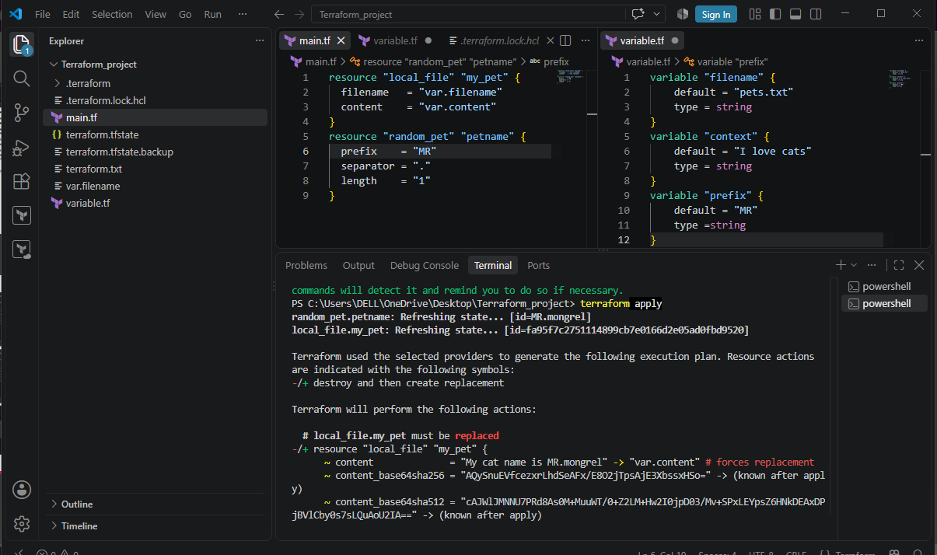
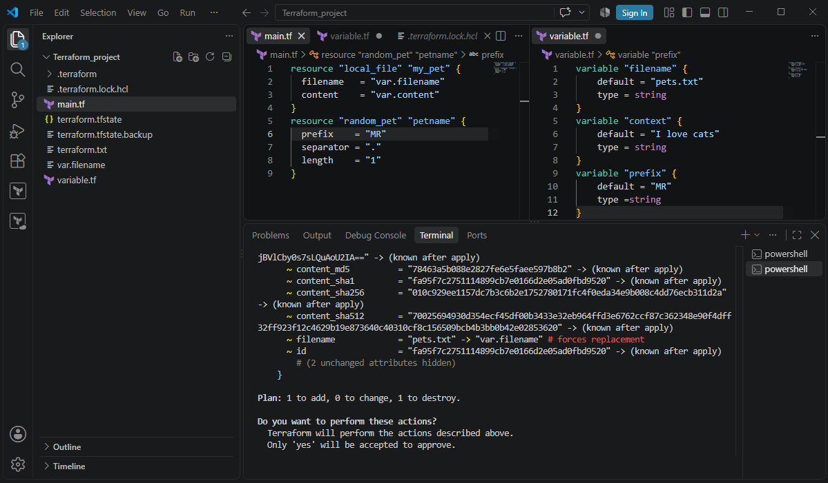

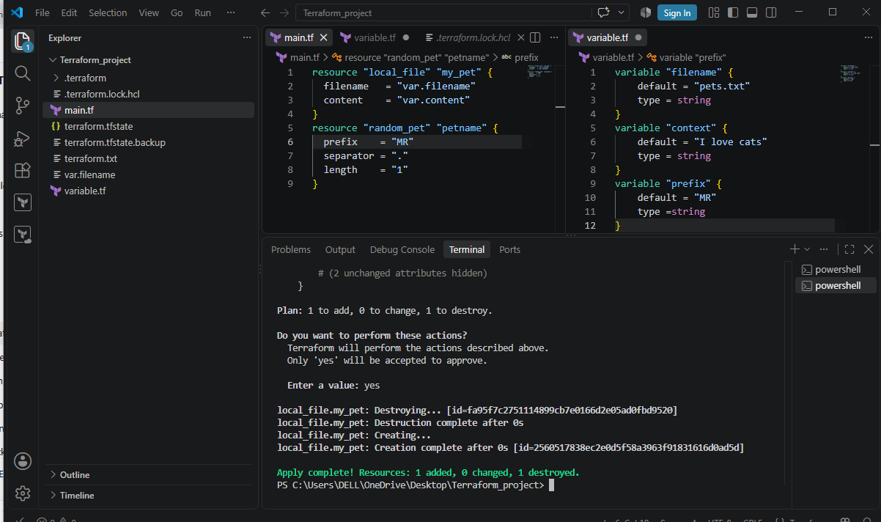
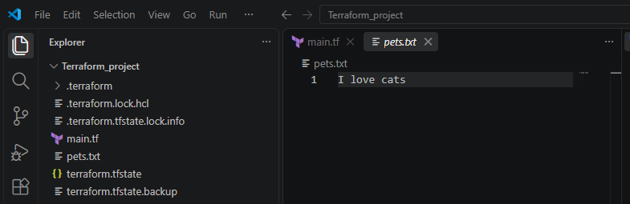

2. By using interactive mode:
If we are declaring empty variables and not passing the default variables then at run time when executing terraform apply it asks to enter the value.
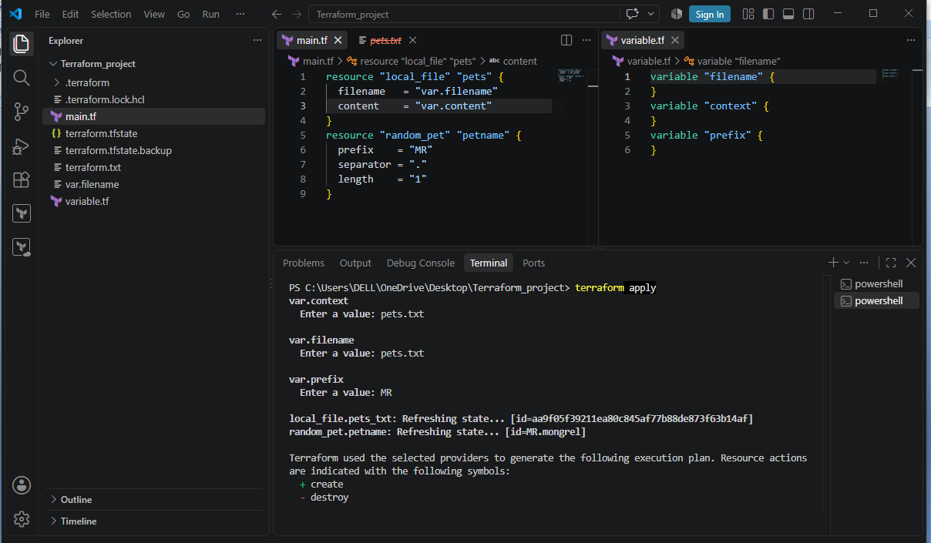
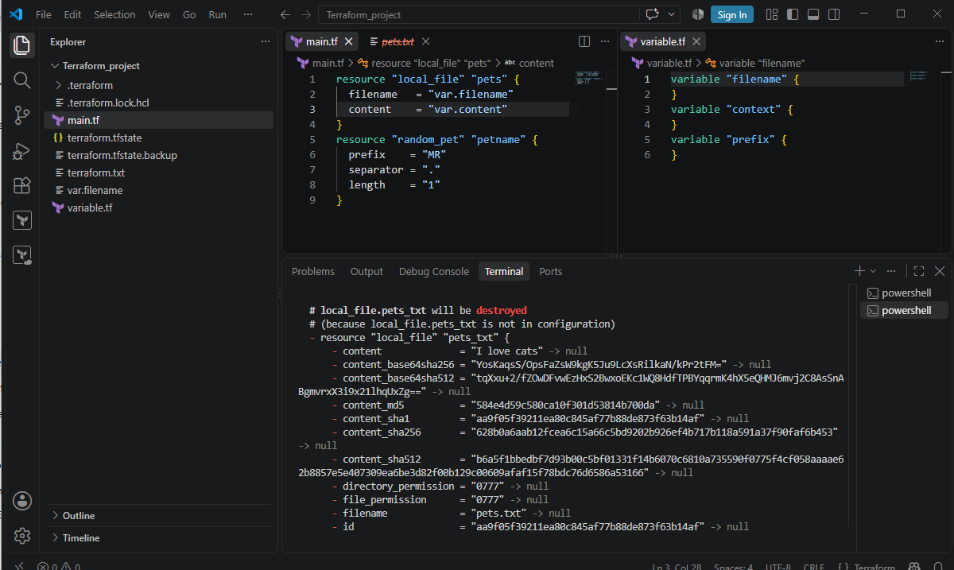

3. Using command line flags:
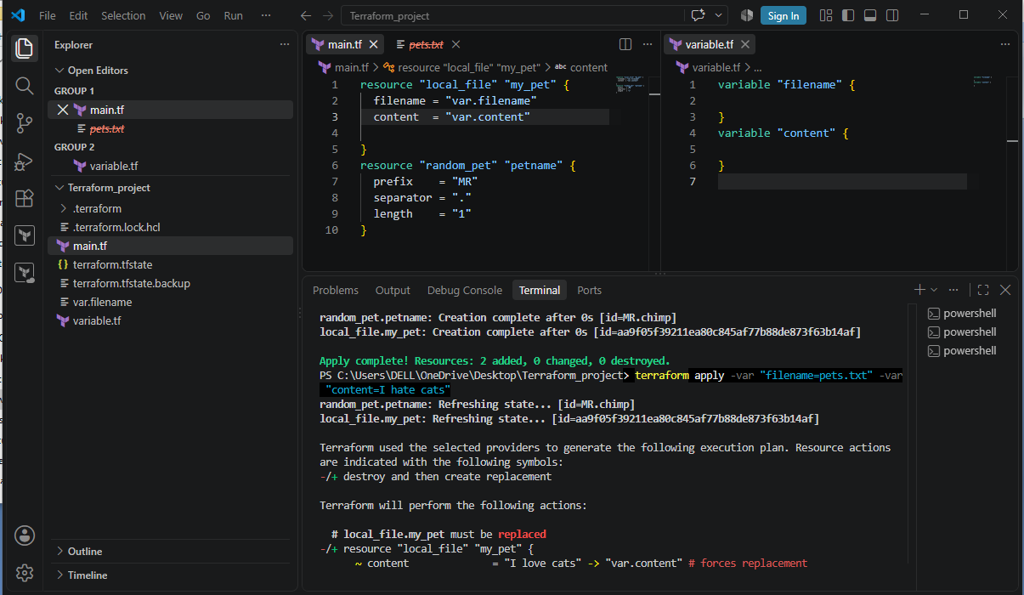
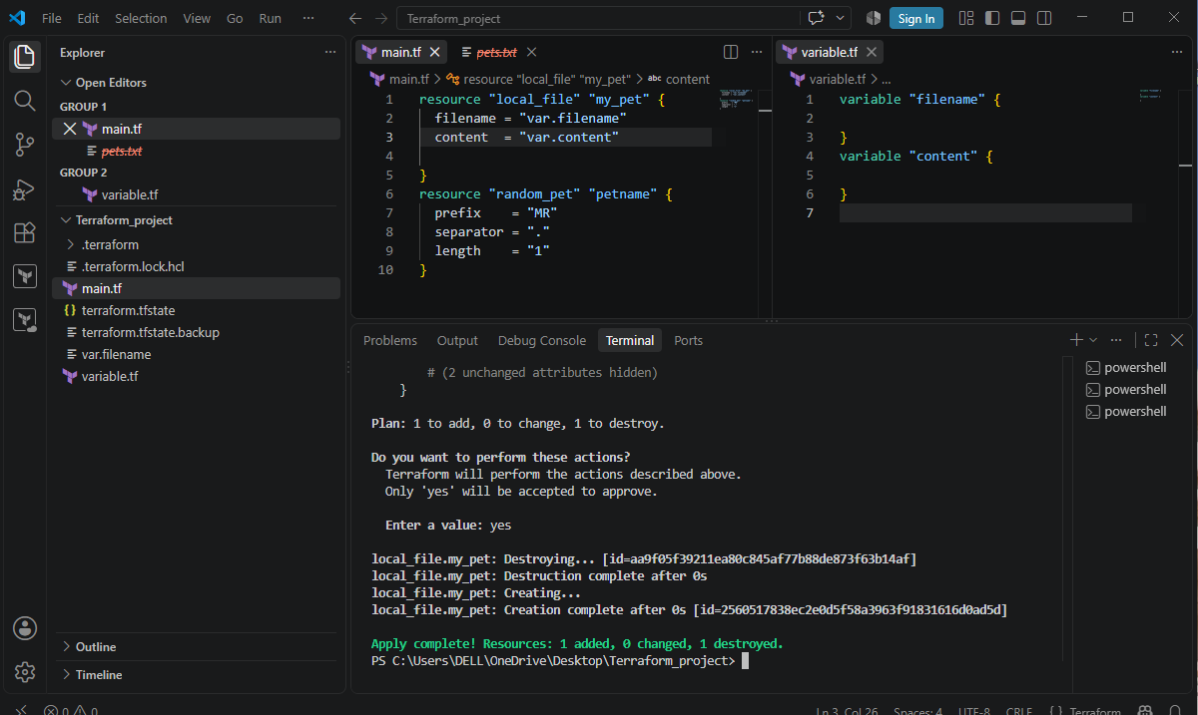
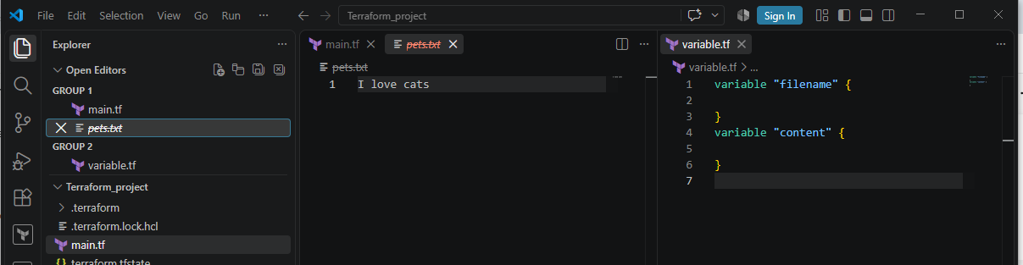

Terraform Lifecycle Rules
Terraform lifecycle rules tell Terraform how to handle a resource when it is created, updated, or destroyed.
There are 3 important lifecycle rules you should know:

1. create_before_destroy
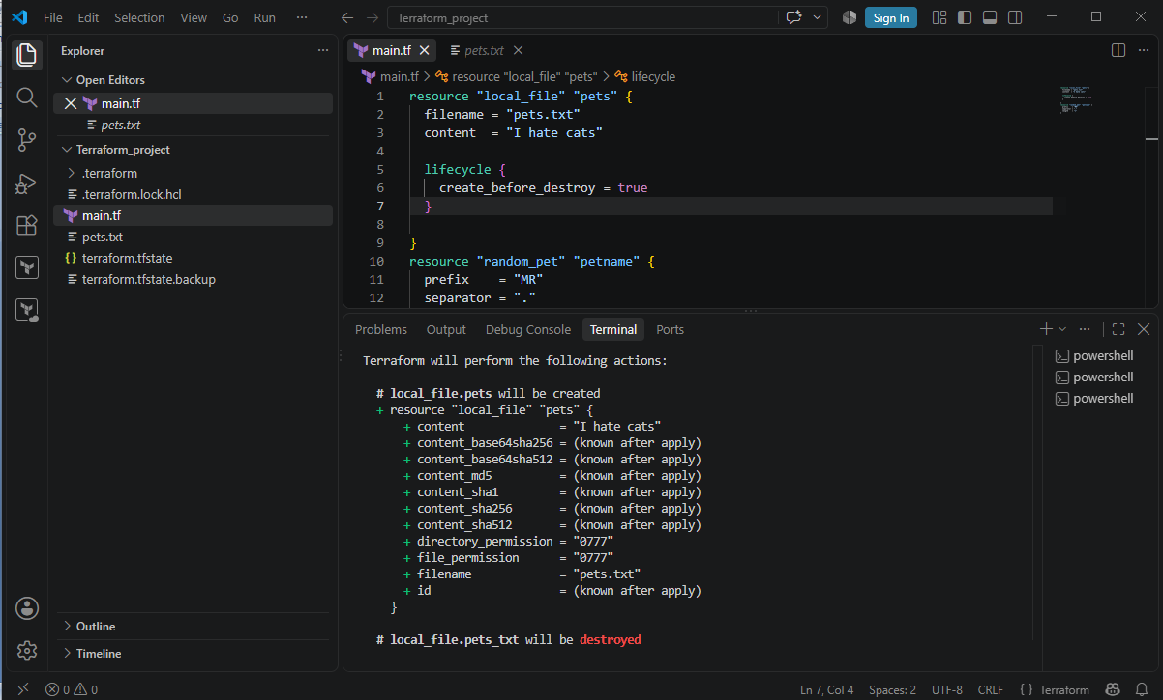
2. prevent_destroy
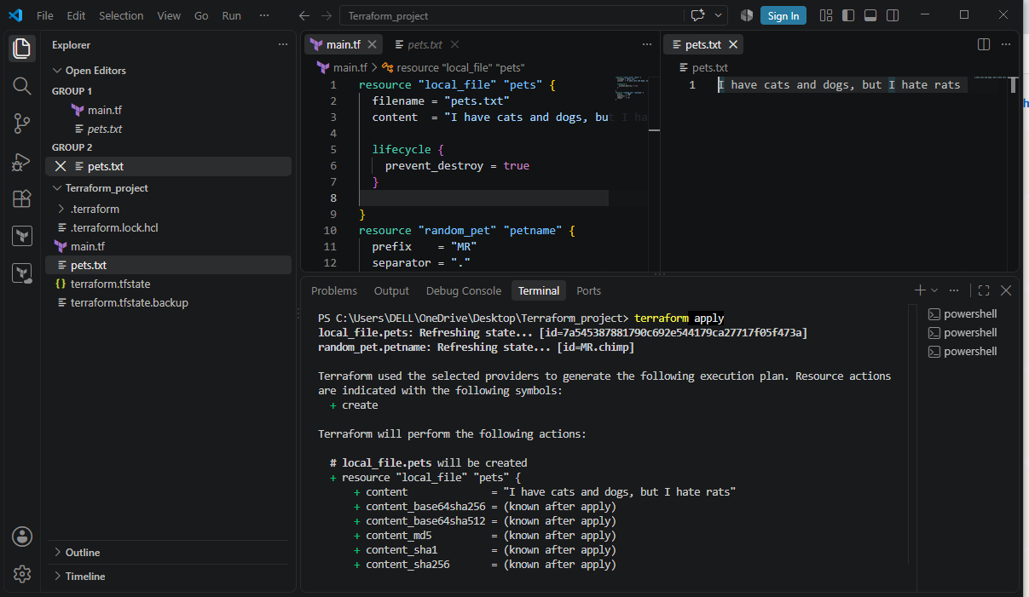

3. Ignore changes
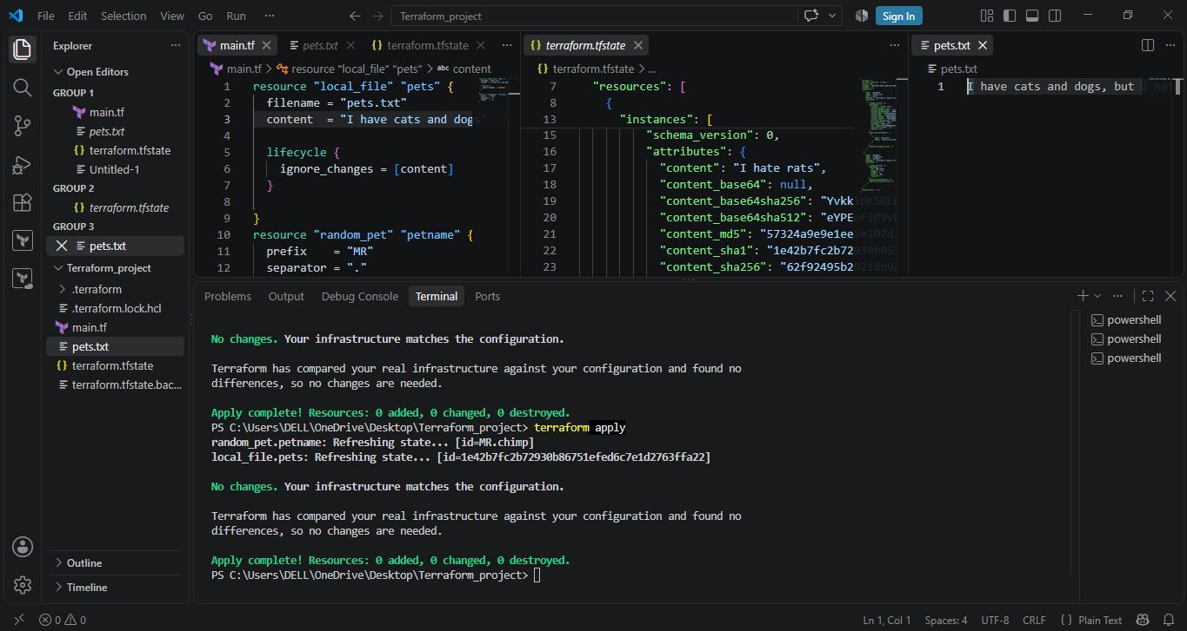
3). Integrate Terraform in Jenkins using the Terraform plugin.
Install Terraform on the Jenkins server/agent
Make sure the terraform command is available.
Step 1:Verify: terraform version
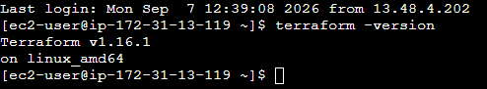

Step 2: Open Jenkins GUI using http://<EC2-PUBLIC-IP>:8080
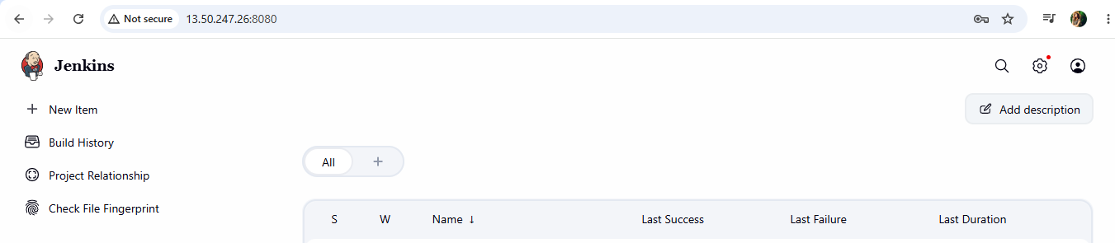

Step 3: Install the Terraform plugin
- Go to Jenkins → Manage Jenkins → Plugins.
- Search for the Terraform plugin and install it.
- Restart Jenkins if required.
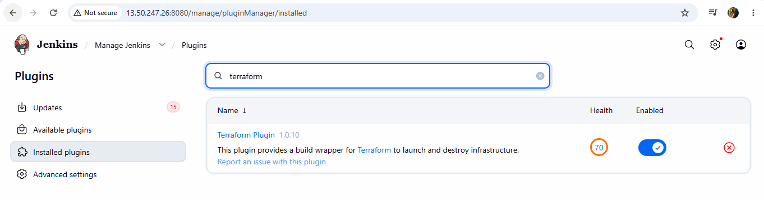
Step 4: Configure Terraform
- Go to Manage Jenkins → Tools.
- Add/configure the Terraform installation.
- Give it a name such as terraform.
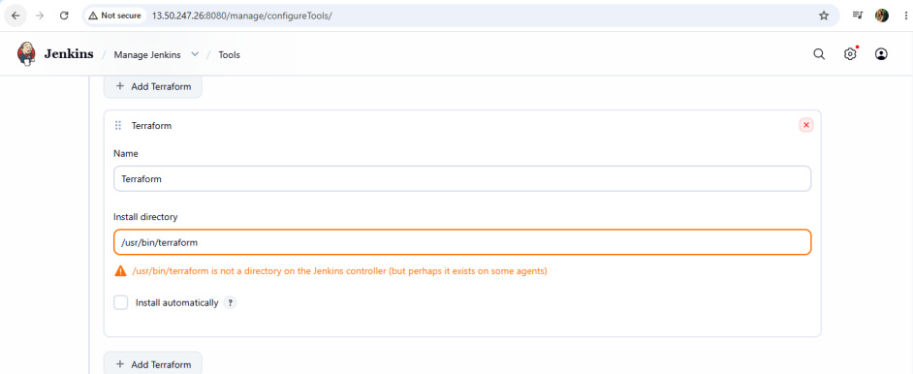
Step 5: Create a Jenkins Pipeline
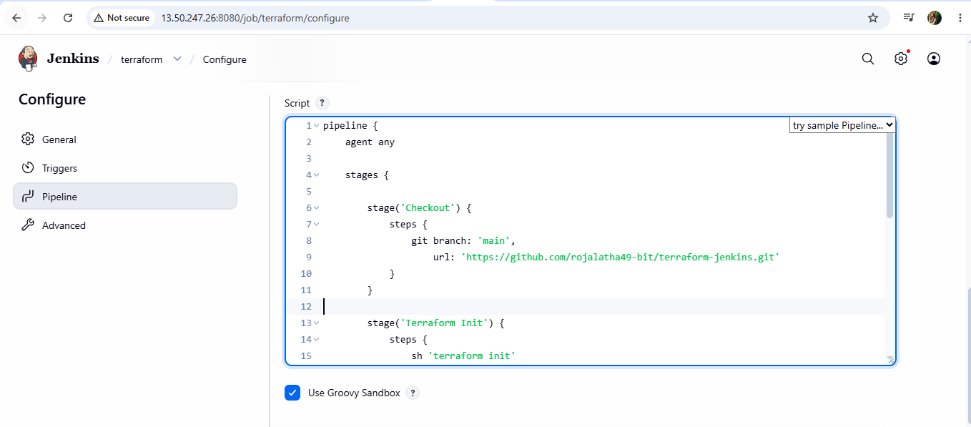
Step 6: Execute the job by clicking ob build now:
